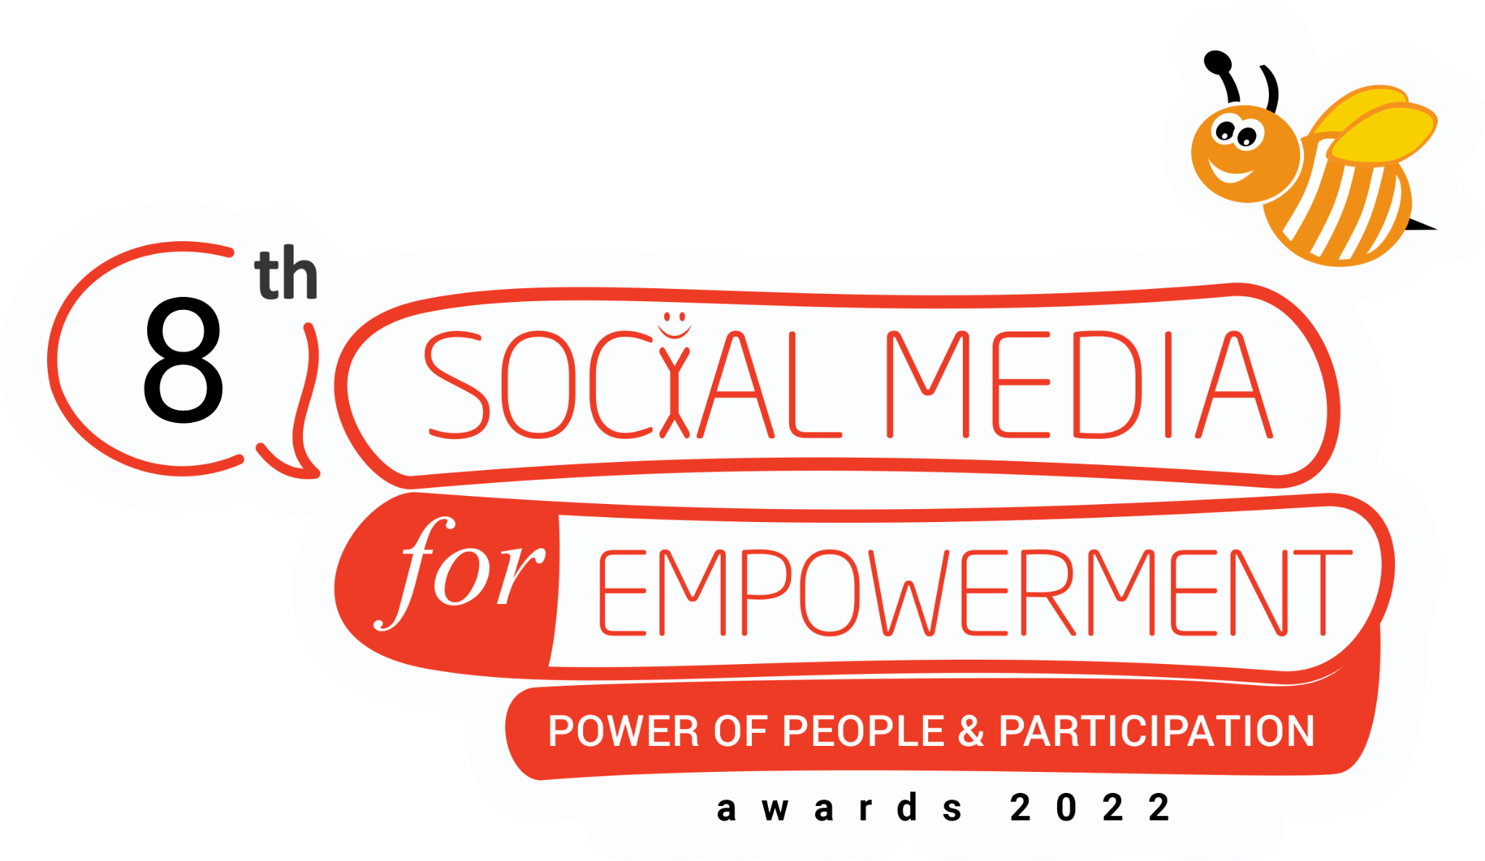
The 8th
Social Media for Empowerment (SM4E) Award South Asia 2022

NOMINATION FORM
The SOCIAL MEDIA FOR EMPOWERMENT (SM4E) AWARD SOUTH ASIA 2022 recognises and felicitates innovations and excellence in SOCIAL MEDIA initiatives in addressing key development and transformation changes through social media innovations and applications across all Countries in the South Asia Region (SAR). We recommend the nominees go through the guidelines before filling up the nomination form. The SM4E Award is being organised since 2013, by the New Delhi, India, by the New Delhi, India, based Digital Empowerment Foundation (DEF) and the World Summit Award (WSA).

ORGANIZATION DETAILS
Organization/Individual Name*
Contact Person*
Mobile No.*
Office Telephone
Email ID*
Website (If Any)
Complete Postal Address*
City*
State*
Country*
*Marked fields are mandatory

- Organisation/individual brief (please provide relevant URLs)
Word limit: 100

- Are you a previous winner of the Social Media for Empowerment Awards South Asia? If yes, we urge you to not apply for the same initiative again.
- Yes
- No

INITIATIVE DETAILS
Category applied for?*
Title of your initiative/project? *
Initiative start Date? (MM/YYYY)*
Current status of the nominated project/application * (the project has to be up and running at least for the past six months on the date of filing the nomination for SM4E Award 2022)

- Brief description of the nominated initiative/application / Solution/ project. *
Write as much as you like but 100 words or so is great!

- Describe the distinctiveness/uniqueness of your initiative.*
Word limit: 100

- Share your social media profile links/URLs*
Facebook
Twitter
Instagram
YouTube
LinkedIn
Snapchat
Pinterest
Tumblr
Any other, please mention

- Mention the primary social media platform you have applied for the initiative you are nominating. How many followers do you have? How has it benefited your initiative?*
Word limit: 100

- List 3 additional social media platforms you used for the initiative you are nominating. How many followers do you have in each of them? How has it benefited your initiative?*
Word limit: 100

- Who is the beneficiary/recipient of the nominee's efforts? Describe the current status of beneficiaries, output and impact. What is the issue that the nominee is trying to address? *
Please write a maximum of 200 words for successful submission.

- Languages and demography the initiative/organisation caters to*
Please be specific, limit 100 words

- How has your company/organization, in the relevant category, made any biggest impact? Also, describe your initiative's end results.
Please be specific, limit 100 words

- Did you employ any marketing/ promotional ad/boost tools to expand your audience and increase engagement? If so, give more details.
Please be specific, limit 100 words

- What difficulties did you encounter when implementing the social media initiative? Describe how you overcame them.
Max 150 words

ADDITIONAL INFORMATION
- Upload your organisation/initiative logo* (.CDR/.PSD/.EPS/.PNG/.JPG format)
Attach a file (Max : 2MB)
- Share 5 high-resolution images that represent your initiative
Attach a file (Max: 10MB)
- Share a presentation about your initiative (only 5 slides)*
Attach a file (Max: 25MB)
- Supporting documents, if any (You can share case studies, photos, research reports or any other document. Files can be uploaded only in DOC., DOCX., PDF, .PPT, .PPTX, AND . SWF format)
Attach a file
- Any other link to useful online resources about your initiative (video links, online material, journals etc.)
Attach a file
*Marked fields are mandatory. All images should be in printable format.

